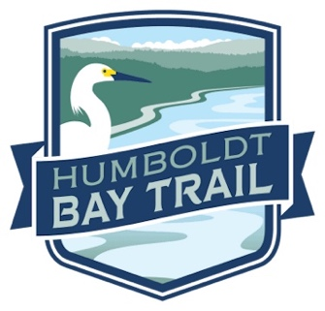
Humboldt Bay Trail Fund Request for Proposals
The Humboldt Bay Trail Fund Committee welcomes proposals from public agencies and community organizations to participate in the development, maintenance, and improvement of the Humboldt Bay Trail.
The Humboldt Bay Trail Fund was established in April of 2017 to provide financial support for the maintenance and creation of multipurpose trails around Humboldt Bay for walking, running, biking and wheeling. The fund is administered by the Humboldt Area Foundation and is overseen by the Humboldt Bay Trail Fund Committee. The seven-member Humboldt Bay Trail Committee is composed of four community members at large, representing trail stakeholders from a broad spectrum of the community, and three public agency representatives from the City of Arcata, the City of Eureka, and the Humboldt County Public Works Department. One of the four at-large members is a representative from the Humboldt Trails Council.
Projects or programs proposed to the Humboldt Bay Trail Fund Committee for funding must demonstrate direct benefits to the Humboldt Bay Trail and should be consistent with funding priorities and do one or more of the following:
- Leverage investment, matching funds or contribute to fund development
- Enhance community visibility and engagement
- Broaden community involvement
- Enhance public safety and comfort on the trail
Proposals should address one or more of the Humboldt Bay Trail Fund priorities, listed in preferential order:
- Maintenance and rehabilitation, with an emphasis on projects involving community volunteers
- Emergency repair projects
- Trail amenities (signs, benches, lighting, landscaping)
- Cost-share to state or federal grant funds for project development (planning, engineering design, technical studies, permitting, and/or construction)
Grant awards generally range from $500-$10,000, although larger, compelling projects will be considered. Grantees must provide full accounting of how grant monies were spent, submit invoices consistent with the approved proposal, and agree to submit a brief, annual, narrative report summarizing the work completed, including before and after photographs, to highlight the benefits to the trail and trail users. Grant funds are paid on a reimbursable basis. Multiyear proposals are welcome. Proposals should specify the completion dates.
Applicants must use the attached grant application. Applicants are required to show proof of coordination with the local government where the project is being proposed. Applicants should be a public agency, a 501(c)(3) nonprofit, or partner with a fiscal sponsor. For additional information on eligibility, please contact beth.burks@hcaog.net.
Application Deadline: February 3, 2022, 5 p.m.
Applications must be emailed or delivered to HCAOG by the due date.
Submit applications to: beth.burks@hcaog.net
Humboldt County Association of Governments
611 I Street, Suite B
Eureka, CA 95501
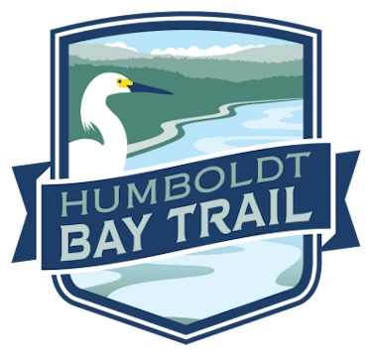
GRANT APPLICATION
Proposal Title:
Amount Requested:
Organization Name:
Primary Contact Name:
Email:
Phone:
Mailing Address:
Humboldt Bay Trail Fund Priority met through proposal (check all that apply)
☐Priority #1 – Maintenance and rehabilitation, with an emphasis on projects involving community volunteers
☐Priority #2 – Emergency repair projects
☐Priority #3 – Trail amenities (signs, benches, lighting, landscaping)
☐Priority #4 – Cost-share to state or federal grant funds for project development (planning, engineering design, technical studies, permitting, and/or construction)
Proposal Summary (150-word limit)

Proposal Details (maximum two pages)
Attach a project description that addresses the following points:
- Describe what you will be doing through this grant. Include location of project and goals. Examples of discussion items include, but are not limited trail benefits, trail user benefits, viewshed and safety improvements, short-term actions that will decrease long-term maintenance needs, ways to increase and encourage public use.

- How does your proposal meet one or more the following funding criteria?

  - Leverages investment, includes matching funds or contributes to fund development
  - Enhances community visibility and engagement
  - Broadens community involvement
  - Enhances public safety and comfort on the trail

- Who will be responsible for the work outlined in the proposal? Describe their qualifications to effectively manage and report on the outcomes of this proposal.

- Which agency(s) have you coordinated with where the work is being proposed? (Please include contact names)

Proposal Schedule (maximum 1 page)
Provide a schedule (narrative description or table) for the work to be accomplished. The schedule should include a brief description of each task (and subtasks if applicable) to be completed, with a start and end date.
Proposal Budget
Use the table format provided below to list all items needed (including paid and volunteer time) for each task in your project. For consistency, use the same tasks that are listed in the proposal schedule. Add additional rows to the table as needed.
Include what items you are requesting from the fund as well as the cash or in-kind value of what you have secured. Where applicable, proposal budgets should include the value of in-kind support (donated goods or services). Use the Independent Sector’s current value of volunteer time.
For multiyear proposals where the same tasks will be completed each year, break out tasks on a yearly basis. For example, if you are proposing to fund a trail steward position for three years, list each year as a separate task (Trail steward year 1, trail Steward year 2, etc.)

Year funds will be expended | Task | Description of Items Needed to complete tasks | Requested from Fund | Secured Cash or Value of In-kind Donation | Total Project Budget
 |  |  | $
 |  |  | $
 |  |  | $
 |  |  | $
 |  |  | $
 |  |  | $
 | Totals: |  | $
If necessary, provide additional explanation about requested or in-kind items:

